**Assignment : Database Development**

For Learner Use:

|  |  |
| --- | --- |
| Surname of Learner | Naidu |
| Name of Learner | Kian |
| Learner ID | 0110105463084 |
| Student Number | KNPMB070 |
| Date of Test Given | 24/07/2020 |
| Location / Branch | iStudent Academy, Durban |

For Assessors Use:

|  |  |
| --- | --- |
| Name of Branch | Durban |
| Name of Facilitator |  |
| Name of Assessor |  |
| Assessor Number |  |
| Mark Allocation | 52 |
| Mark Obtained |  |
| Competency Status (C / NYC) |  |

|  |  |
| --- | --- |
| Unit Standards MICT Seta | 115373, 114048, 114049 |

|  |  |  |  |
| --- | --- | --- | --- |
| Candidates Signature | C:\Users\KIAN\Desktop\(KNPMB070)Kian Naidu.JPG | Date of Submission | 17/08/2020 |
| Assessors Signature |  | Date Marked |  |

**Instructions**

The candidate must complete the assignment using SQL statements and scripts on a SQL database.

Learners should produce the following for their Assessor:

• test plan

• test data (queries list)

• test log

• cross-referenced evidence of testing i.e. printout of script file and test output as necessary to show test results.

**Grading criteria**

Not Yet Competent – did not meet all criteria shown as [ ]

Competent – criteria shown as [ ] and 28 shown as ( )

Credit – criteria shown as [ ] and 34 shown as ( ).

Distinction - criteria shown as [ ] and 38 shown as ( ).

**Requirements**

To complete this assignment, you will require:

* SQL Server
* Windows 8.1 or later
* Working laptop or PC

Please ask for assistance from your Assessor, should you require it, to install SQL on your machine in working order!

**Scenario**

A company, Delta Books who supply educational books, have their Head Office in America and operate other branches in several locations. You work as an IT Assistant accessing the company database, fulfilling requests for information and services from other departments or branches. Your job involves writing and testing SQL queries to provide the information and services required.

The following requests have been received today, via fax and e-mail, from Finance, Human Resources and the Database Administrator.

|  |  |
| --- | --- |
| **Finance Requirements** | |
| Request 1 | List the last name, first name and employee number of all employees that have a last name starting with M. |
| Request 2 | List the department number, last name, first name and phone number of all sales representatives who were hired on or after 24 Mar 1998 sorted in ascending order of last name. |
| Request 3 | List all the data for all jobs where the minimum salary is less than or equal to 4500 sorted in descending order of the minimum salary. |
| Request 4 | Which jobs are found in the Marketing and Accounting departments? |
| Request 5 | List the department name, location, last name and salary of employees who work in location 1700 sorted in ascending order of department name. |
| Request 6 | List the last name and first name for all employees who were hired in the months of June or August (for all years) sorted in ascending order of last name. |
| Request 7 | Show the average salary for employees for one year (rounded to 2 decimal places). |
| Request 8 | Show the total monthly salaries figure (0 decimal places) for all employees in departments 80 and 60. |

|  |  |
| --- | --- |
| **Human Resources Requirements** | |
| Request 9 | List the department number, department name and the number of employees for each department that has less than 4 employees grouping by department number and department name. |
| Request 10 | List the department number, department name and the number of employees for the department that has the lowest number of employees using appropriate grouping. |
| Request 11 | List the department number and name for all departments where no sales representatives work. |
| Request 12 | Add the following new job  IT_ASST, IT Assistant, 5000, 8000 |
| Request 13 | Update all the minimum salaries for jobs with an increase of 500. |
| Request 14 | List all the data for jobs sorted in ascending order of job id. |

|  |  |
| --- | --- |
| **Database Administrator Requirements** | |
| Request 15 | The database administrator has found the following entity-relationship diagram. He thinks that the diagram is incorrect. Check the diagram and draw a corrected diagram. |
| Request 16 | Print a copy of the data dictionary entry for the table departments. |
| Request 17 | Drop the table for job history. |
| Request 18 | Create a new table called SAL_HISTORY to include the fields EMPID, FIRSTNAME, LASTNAME, HIREDATE and SAL with the same data types as the employees table. The EMPID must not be NULL. |
| Request 19 | Insert data from the employees table where the employee number is less than or equal to 130 into the SAL_HISTORY table. |
| Request 20 | Display all the records and all the fields in the SAL_HISTORY table. |

1. Prepare a test plan to carry out the testing of the SQL queries.

|  |  |  |  |  |  |  |  |  |  |  |  |  |  |  |  |  |  |  |  |  |  |  |  |  |  |  |  |  |  |  |  |  |  |  |  |  |  |  |  |  |  |  |  |  |  |  |  |  |  |  |  |  |  |  |  |  |  |  |  |  |  |  |  |
| --- | --- | --- | --- | --- | --- | --- | --- | --- | --- | --- | --- | --- | --- | --- | --- | --- | --- | --- | --- | --- | --- | --- | --- | --- | --- | --- | --- | --- | --- | --- | --- | --- | --- | --- | --- | --- | --- | --- | --- | --- | --- | --- | --- | --- | --- | --- | --- | --- | --- | --- | --- | --- | --- | --- | --- | --- | --- | --- | --- | --- | --- | --- | --- |
| |  |  |  | | --- | --- | --- | | Test Name | Expected Outcome | Actual outcome | | Request1 | Listing the last name, first name and employee number of all employees that have a last name starting with M. | Listing the last name, first name and employee number of all employees that have a last name starting with M. | | Request2 | Listing the department number, last name, first name and phone number of all sales representatives who were hired on or after 24 Mar 1998 sorted in ascending order of last name. | Listing the department number, last name, first name and phone number of all sales representatives who were hired on or after 24 Mar 1998 sorted in ascending order of last name. | | Request3 | Listing all the data for all jobs where the minimum salary is less than or equal to 4500 sorted in descending order of the minimum salary. | Listing all the data for all jobs where the minimum salary is less than or equal to 4500 sorted in descending order of the minimum salary. | | Request4 | Selecting jobs found in the Marketing and Accounting departments | Selecting jobs found in the Marketing and Accounting departments | | Request5 | Listing the department name, location, last name and salary of employees who work in location 1700 sorted in ascending order of department name. | Listing the department name, location, last name and salary of employees who work in location 1700 sorted in ascending order of department name. | | Request6 | Listing the last name and first name for all employees who were hired in the months of June or August (for all years) sorted in ascending order of last name. | Listing the last name and first name for all employees who were hired in the months of June or August (for all years) sorted in ascending order of last name. | | Request7 | Showing the average salary for employees for one year (rounded to 2 decimal places). | Showing the average salary for employees for one year (rounded to 2 decimal places). | | Request8 | Showing the total monthly salaries figure (0 decimal places) for all employees in departments 80 and 60. | Showing the total monthly salaries figure (0 decimal places) for all employees in departments 80 and 60. | | Request9 | Listing the department number, department name and the number of employees for each department that has less than 4 employees grouping by department number and department name. | Listing the department number, department name and the number of employees for each department that has less than 4 employees grouping by department number and department name. | | Request10 | Listing the department number, department name and the number of employees for the department that has the lowest number of employees using appropriate grouping. | Listing the department number, department name and the number of employees for the department that has the lowest number of employees using appropriate grouping. | | Request11 | Listing the department number and name for all departments where no sales representatives work. | Listing the department number and name for all departments where no sales representatives work. | | Request12 | Adding the following new job  IT_ASST, IT Assistant, 5000, 8000 | Adding the following new job  IT_ASST, IT Assistant, 5000, 8000 | | Request13 | Updating all the minimum salaries for jobs with an increase of 500. | Updating all the minimum salaries for jobs with an increase of 500. | | Request14 | Listing all the data for jobs sorted in ascending order of job id. | Listing all the data for jobs sorted in ascending order of job id. | | Request15 | Drawing a corrected diagram. | Drawing a corrected diagram. | | Request16 | Printing a copy of the data dictionary entry for the table departments. | Printing a copy of the data dictionary entry for the table departments. | | Request17 | Dropping the table for job history. | Dropping the table for job history. | | Request18 | Creating a new table called SAL_HISTORY to include the fields EMPID, FIRSTNAME, LASTNAME, HIREDATE and SAL with the same data types as the employees table. The EMPID must not be NULL. | Creating a new table called SAL_HISTORY to include the fields EMPID, FIRSTNAME, LASTNAME, HIREDATE and SAL with the same data types as the employees table. The EMPID must not be NULL. | | Request19 | Inserting data from the employees table where the employee number is less than or equal to 130 into the SAL_HISTORY table. | Inserting data from the employees table where the employee number is less than or equal to 130 into the SAL_HISTORY table. | | Request20 | Displaying all the records and all the fields in the SAL_HISTORY table. | Displaying all the records and all the fields in the SAL_HISTORY table. | |

1. Below, write which queries are to be used for each request.

|  |
| --- |
| --Request 1  SELECT LastName,FirstName,EmpID FROM Employees WHERE LastName LIKE 'M%';  --Request 2  SELECT e.DeptNo,e.LastName,e.FirstName,e.Phone FROM Employees AS [e]  INNER JOIN Jobs AS [j] ON e.JobID = j.JobID  WHERE (j.Field = 'Sales rep') AND (e.Hiredate<='1998-03-24') ORDER BY e.LastName;  --Request 3  SELECT * FROM Jobs WHERE MinSal <= 4500 ORDER BY MinSal DESC;  --Request 4  SELECT Field AS [Job] FROM Jobs AS [j] INNER JOIN Employees AS [e] ON j.JobID = e.JobID  WHERE (e.DeptNo = 20) OR (e.DeptNo = 40)  GROUP BY Field;  --Request 5  SELECT d.DeptName,l.[Location],e.LastName,e.Sal FROM Employees AS [e] INNER JOIN Departments AS [d]  ON e.DeptNo=d.DeptNo INNER JOIN Locations AS [l] ON l.DeptNo=d.DeptNo  WHERE [Location] = '1700' ORDER BY DeptName;  --Request 6  SELECT LastName,FirstName FROM Employees WHERE (Month(Hiredate)=6) OR (Month(Hiredate)=8) ORDER BY LastName;  --Request 7  SELECT FORMAT(AVG(Sal),'R00.00') AS [Average Annual Salary] FROM Employees;  --Request 8  SELECT FLOOR(Sal/12) AS [MonthlySalary] FROM Employees WHERE (DeptNo = 80) OR (DeptNo= 60);  --Request 9  SELECT d.DeptNo,d.DeptName,Count(e.EmpID) AS [NumEmployees] FROM Departments AS [d]  INNER JOIN Employees AS [e] ON d.DeptNo=e.DeptNo  GROUP BY d.DeptNo,d.DeptName HAVING Count(e.EmpID) < 4;  --Request 10  SELECT TOP(1) d.DeptNo,d.DeptName,Count(e.EmpID) AS [NumEmployees] FROM Departments AS [d]  INNER JOIN Employees AS [e] ON d.DeptNo=e.DeptNo  GROUP BY d.DeptNo,d.DeptName  ORDER BY NumEmployees;  --Request 11  SELECT DeptNo,DeptName FROM Departments  WHERE DeptName <> 'Marketing';  --Request 12  INSERT INTO Jobs(JobID,Field,MinSal,MaxSal)  VALUES  ('IT_ASST', 'IT Assistant', 5000, 8000 );  --Request 13  UPDATE Jobs SET MinSal = MinSal+500;  --Request 14  SELECT * FROM Jobs ORDER BY JobID;  --Request 17  CREATE TABLE Job_History  (  JobID varchar(20) NOT NULL PRIMARY KEY,  Field varchar(40),  MinSal decimal(19,4),  MaxSal decimal(19,4)  );  GO  DROP TABLE Job_History;  --Request 18  CREATE TABLE Sal_History  (  EmpID int NOT NULL PRIMARY KEY,  FirstName varchar(255),  LastName varchar(255),  HireDate date,  Sal decimal(19,4)  );  --Request 19  INSERT INTO Sal_History  SELECT EmpID,FirstName,LastName,Hiredate,Sal FROM Employees  WHERE EmpID <= 130  --Request 20  SELECT * FROM Sal_History; |

1. Use the test plan and queries to carry out the tests and record results of testing in a test log comparing the expected results to the actual results. The test queries must be saved with an appropriate name eg Request1.

|  |
| --- |
| Request1: Successful  Request2: Successful  Request3: Successful  Request4: Successful  Request5: Successful  Request6: Successful  Request7: Successful  Request8: Successful  Request9: Successful  Request10: Successful  Request11: Successful  Request12: Successful  Request13: Successful  Request14: Successful  Request15: Successful  Request16: Successful  Request17: Successful  Request18: Successful  Request19: Successful  Request20: Successful |

1. Provide evidence of testing i.e. screenshots of queries run and the result, which must be cross referenced to the correct test number.

|  |
| --- |
| Request1  Request2 |

Request3

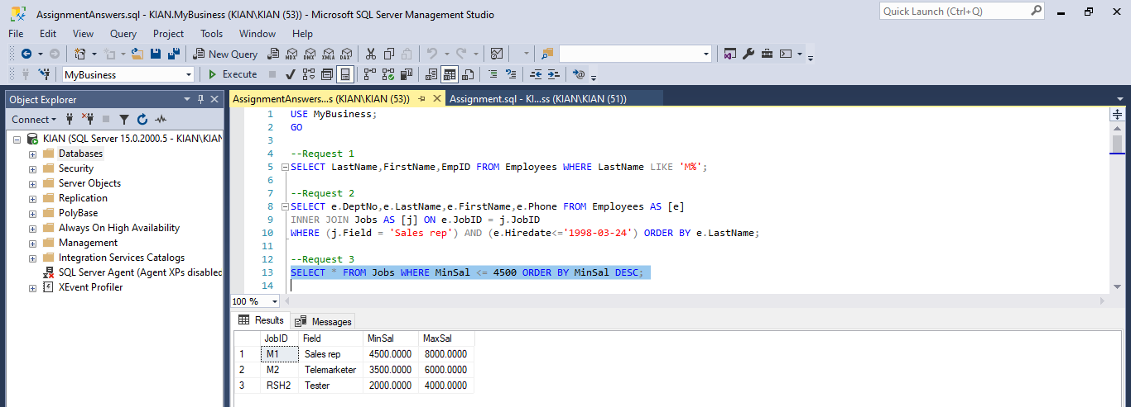

Request4

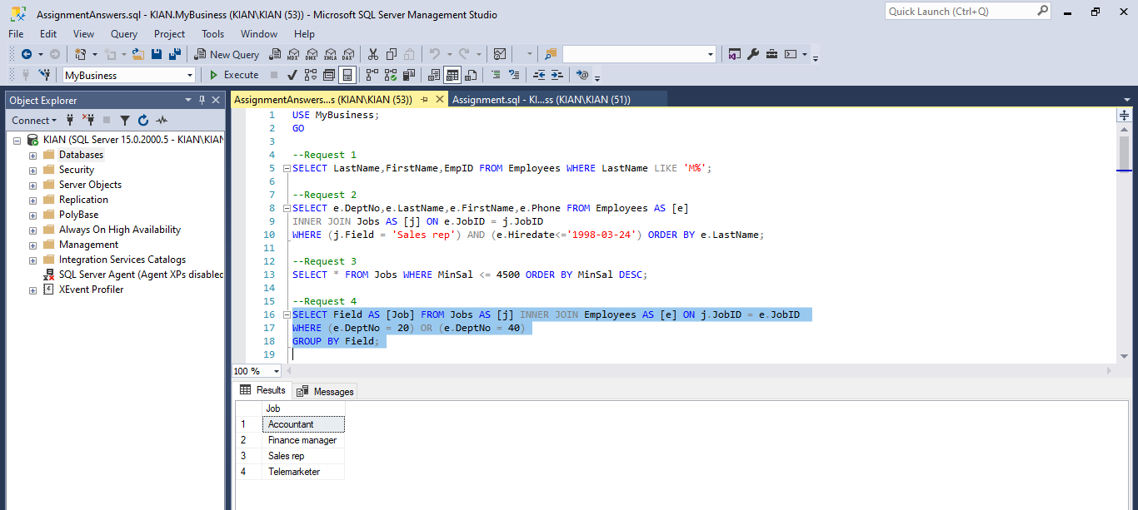

Request5

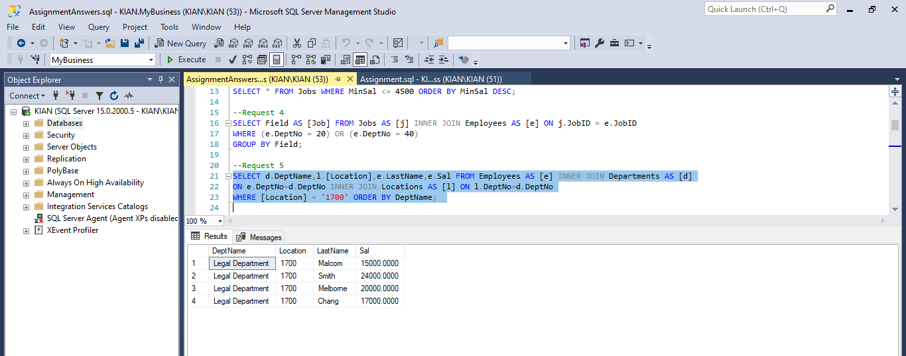

Request6

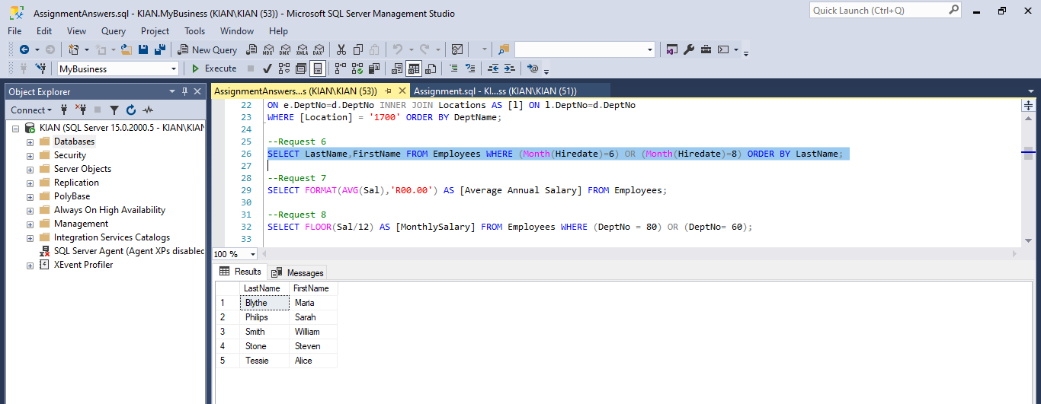

Request7

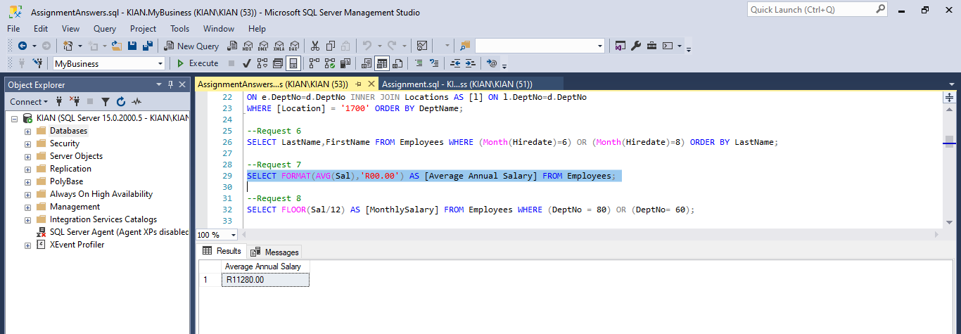

Request8

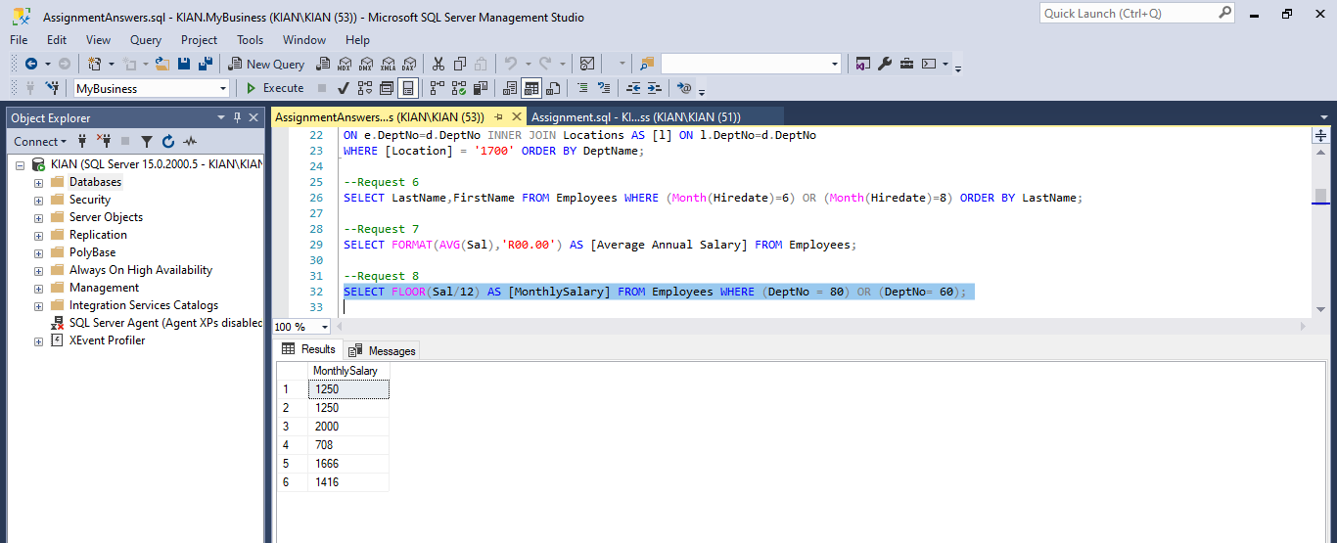

Request9

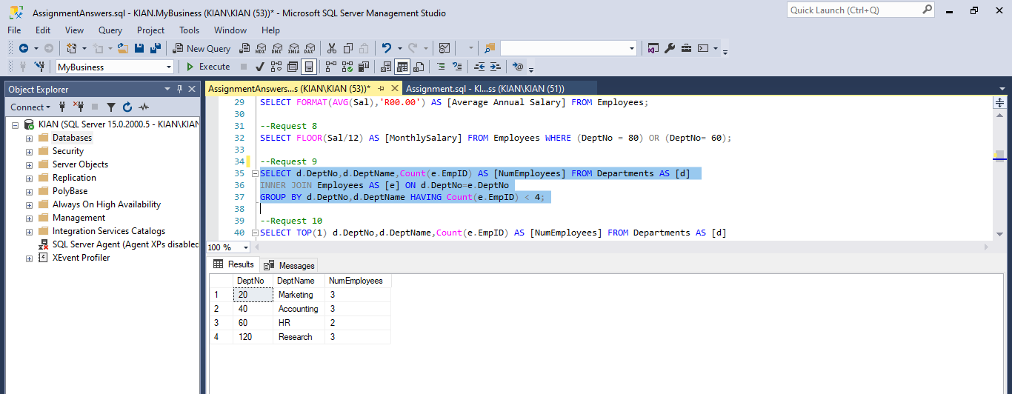

Request10

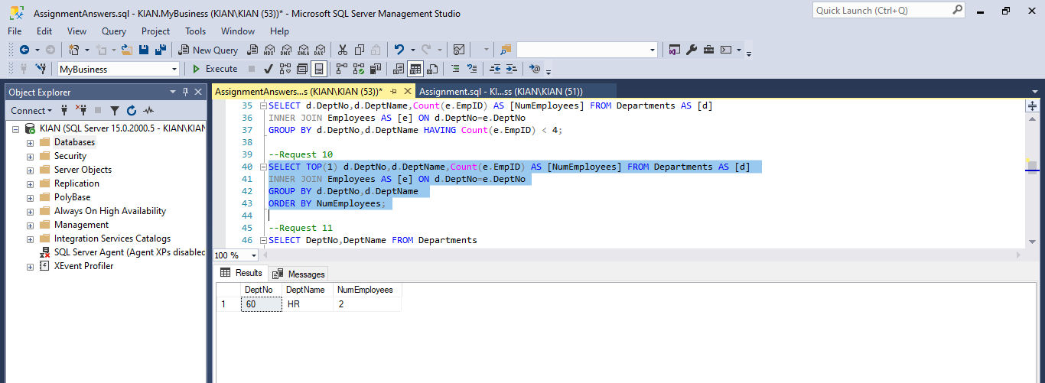

Request11

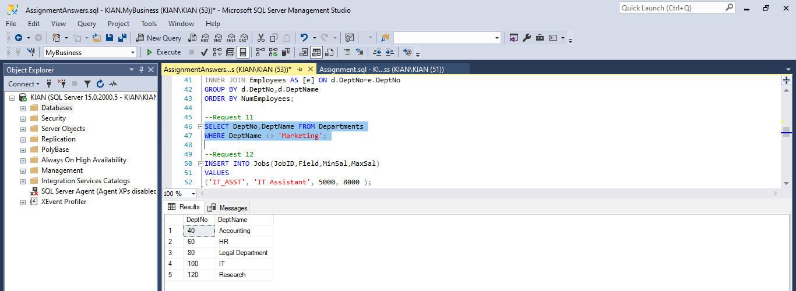

Request12

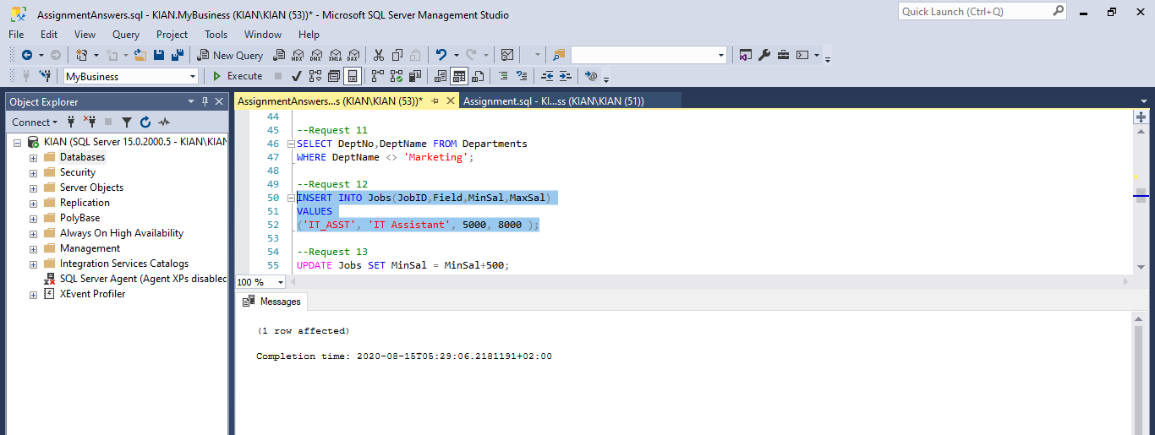

Request13

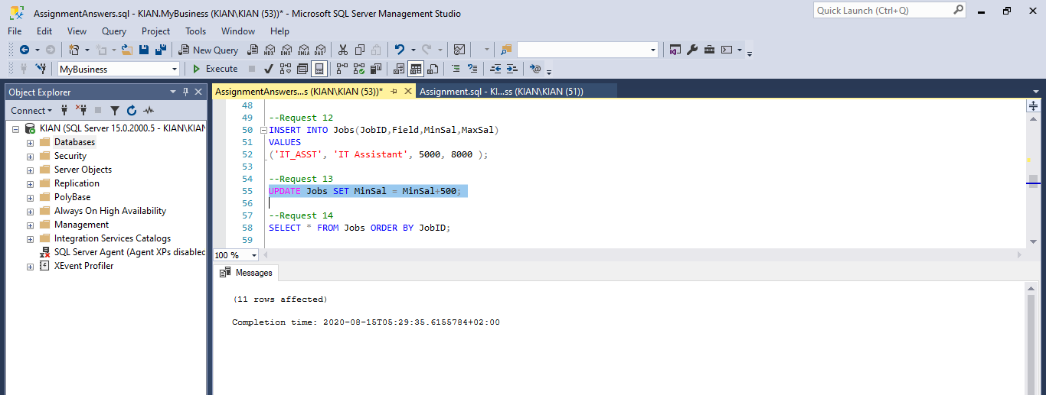

Request14

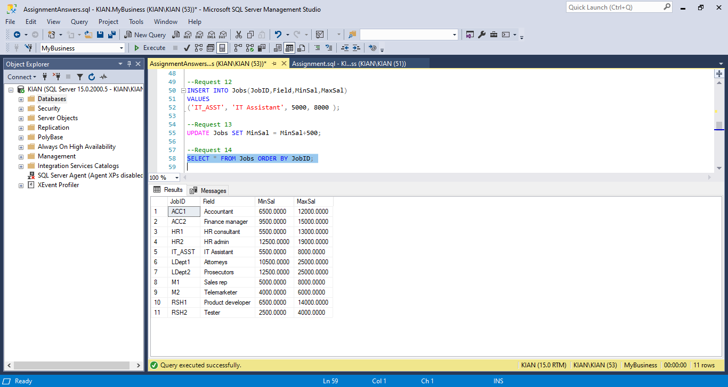

Request15

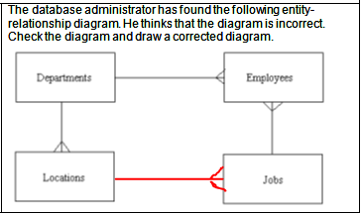

Request16

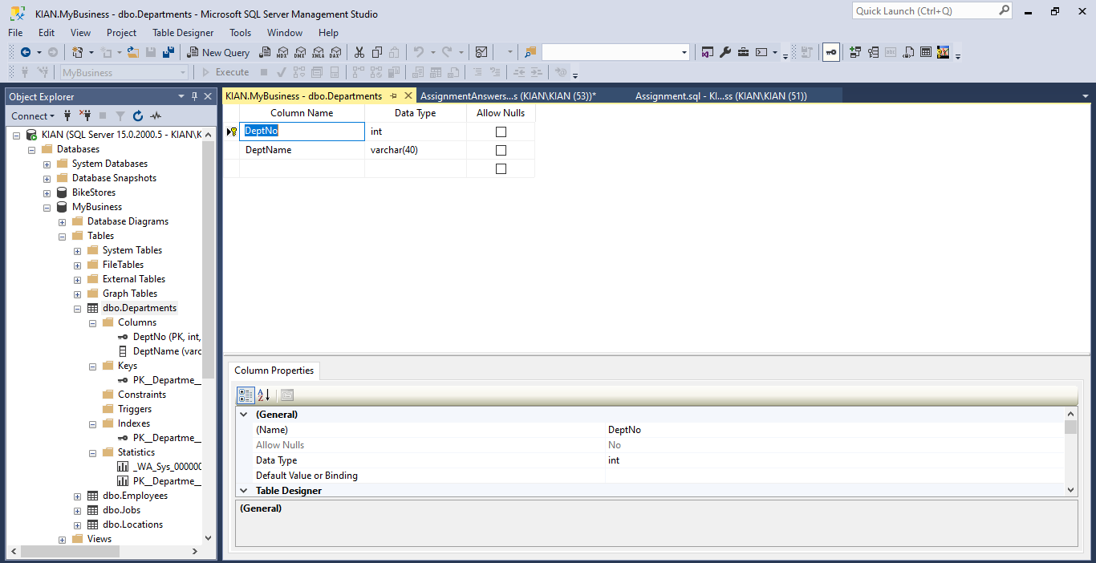

Request17

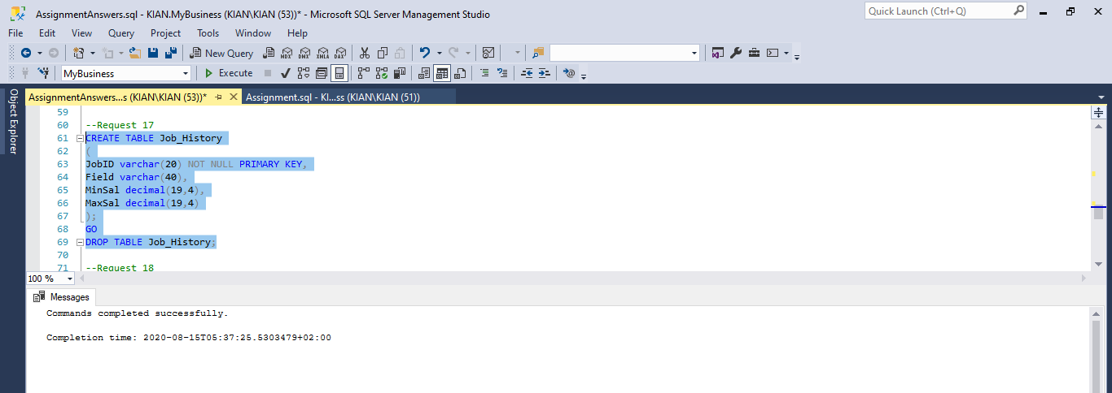

Request18

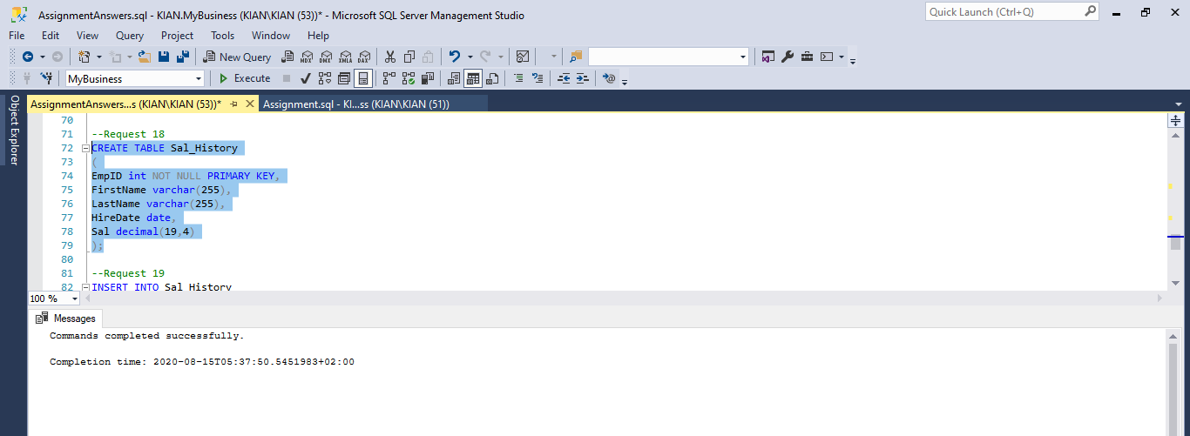

Request19

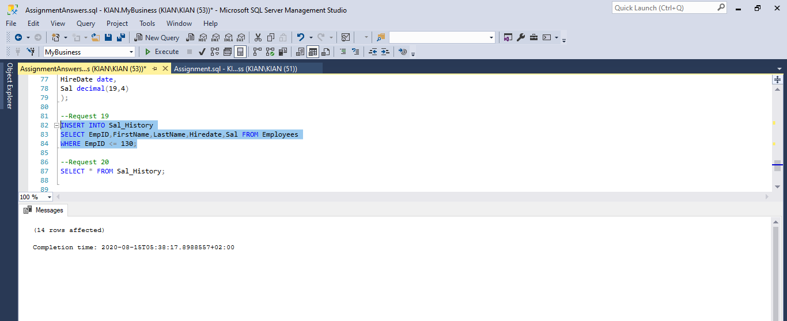

Request20

